Announcement
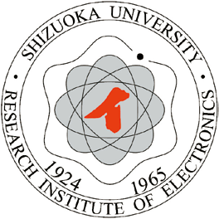
Call for Erasmus+ Mobility Grants 2018/2019

Dear colleagues,
You can apply for a teacher mobility grant – Erasmus+
Place of mobility: Technical University of Kosice in Slovakia (Middle Europe),
Faculty of Mining, Ecology, Process Control and Geotechnologies,
Institute of Earth Resources
Subject area: Chemical engineering and processes
Prerequisites of Participation
Eligible applicants must be employees of Shizuoka University
The sending and receiving organizations must agree on the activities to be undertaken.
(See “Mobility Agreement”) prior to the start of the mobility period. The agreement defines the target learning outcomes for the learning period abroad and lists the rights and obligations of each party.
Duration of the Mobility
The minimum duration for an Erasmus+ Staff Teaching Mobility is 5 working days, maximum – 10 + 2 travel days.
Financial Rules
Selected applicants are eligible to receive funds to partially support their visit. Funds are not expected to fully cover all actual expenses incurred. Funds may cover individual support (subsistence) and travel. The applicant’s unit may supplement the grant to cover remaining costs.
Application Procedure
• Complete the Application Form. Approval required by the head of department and by the host institution
• Complete the Mobility Agreement
(You can get the above form from Prof. Koji Mori)
Submission of Applications
Please submit application package to Prof. Koji Mori
Files: Application form
Mobility Agreement
The deadline to apply is: 27/05/2019

